

Underwood, Trevor M | cs4395 – Independent Study | Dr. Qijun Gu | August 5, 2016

Buffer Overflows and Format Strings

introduction to basic security exploits For Students

# Abstract

Over the past several years, cybersecurity has become an increasingly pressing issue for those at the top levels of government and for companies in both the public, and private sector. Creating a constantly increasing demand for cybersecurity professionals within the workforce. While Texas State offers a cybersecurity class to students it’s an incredibly difficult task to bridge the gap between academic and real world experience.

Cybersecurity enthusiasts and professionals often host, participate, and compete in events known as “capture the flag challenges” for fun, and occasionally monetary gain. The challenges presented in these events are often rooted in present real world vulnerabilities. Using data collected while studying these events I have identified several of the most common vulnerabilities exploited. I will be presenting challenges designed to teach students the basics of these exploits. The vulnerabilities covered are: buffer overflow vulnerabilities, format string vulnerabilities, and shellshock based vulnerabilities. Additionally, I have also prepared several challenges to teach students the basics of reverse engineering binaries.

# Methodology

The information presented in this paper was collected over several months of studying past CTF competitions from the 2014 and 2015 years. The problems studied a cover large portion of topics relevant to cyber-security. Topics including: Binary exploitation, remote system exploitation, web based exploitation, cryptography, forensics, programming, and reverse engineering. While studying these problems the source CTF, year the CTF was held, problem name, description, category, difficulty, vulnerability, solution, and tools used to solve the problem were recorded.

After all available write-ups for CTF events held in 2014 and 2015 were analyzed a comprehensive table of the most common vulnerabilities across all of the categorizes examined was compiled. Using this data, I decided to construct several binary exploitation, remote system exploitation, and reverse engineering challenges in hopes of teaching students interested in cybersecurity about these common vulnerabilities and how to exploit these vulnerabilities themselves.

# Results / Outcome of the Project

Over the course of the semester 100 total CTF competitions were studied, 40 CTF competitions from 2104 and 60 CTF competitions from 2015. In total roughly 1,368 problems were analyzed and categorized. Of these problems ~213 problems involved either binary exploitation, or remote systems exploitation. ~232 problems involved web exploitation, ~254 problems involved cryptography, ~226 problems involved reverse engineering either a provided binary or program code, ~333 problems involved computer forensics, and finally ~110 of the problems instructed individuals to write code to solve a particular problem. If we continue to break down the statistics for each category of problem, I found the most common challenges / vulnerabilities presented for each.

For reverse engineering the most common challenges were: reversing a flag in x86, reversing a flag in x64, and reversing a flag via DEX / APK. These challenges were often solved via tool assistance. The most common challenges presented in the binary exploitation category were: changing the value of a variable, control execution flow to launch arbitrary code, and to break out of ‘code jails’. Solving these binary exploitation challenges usually required the use of data overflows, and stack overflows to re-write values contained on the stack.

Solving cryptography challenges usually involved understanding the implementation of the given cipher, as well as the cipher’s strengths and weaknesses. A majority of the time, understanding the cipher and applying or reversing the ciphers mathematical properties revealed the answer to the challenge. The most common ciphers were: Exclusive OR (XOR), Substitution, AES / AES – EBC, and RSA with weak public keys.

Web challenges usually involved simple tasks such as: finding source code hidden on a given webpage, or stealing login credentials. These challenges were often defeated with the following methods / vulnerabilities: HTML Inspection, JS Inspection, Web Data Inspection (with Wireshark), SQL Injections, Cross Site Scripting – XSS, and PHP Exploitation.

Finally, data forensics challenges generally involved finding hidden data in the following files: PCAP files (web traffic), PDF files, encrypted PDF Files, sound files such as WAV files, picture files of various formats, and finally obfuscated code. Data forensics challenges often rely heavily on tool assistance. Some of the most commonly used tools were: Wireshark, peepdf, pdfcrack, ffmpeg, audacity, foremost, image magic, binwalk, and a simple JS console.

After compiling and analyzing all of the data, I decided to write several reverse engineering and binary exploitation challenges for students. The goal of these challenges is to introduce aspiring computer security students to these common vulnerabilities and teach students how to exploit these vulnerabilities.

# Conclusion and Future Works

Participating in cyber security competitions is an excellent way for any aspiring computer security enthusiast or professional to combine his or her academic knowledge with real world experience.

Using data collected from cyber security competitions hosted within the last two years I have identified several common challenges presented to competitors during these competitions throughout each of the major categories of computer security. Additionally, I also identified several common vulnerabilities and exploits for each major category.

Finally, to continue moving this research forward I would like to begin the development of a cyber-security training platform for Texas State students using the data collected during this research. I believe if Texas State’s Computer Science department developed it’s very own training platform for students the platform if would be an excellent interactive learning tool supplementing students’ academic knowledge with real world experience provided in a controlled environment.

# References

All of the data collected during this independent study can be found online on GitHub at the following link: [CTF Repo](https://github.com/ctfs). These repositories are managed by users: Abpolym, and Dhanvi. Special thanks should also be given to all of the computer security enthusiasts who populate this repository with their write-ups.

Without them, none of this would be possible.

# Intro to Reverse Engineering:

DoYouKnowStrings

Introduction:DoYouKnowStrings is an easy challenge designed to teach students how to perform a basic analysis against a target binary to learn more about it. Using the commands discussed in this write up should be one of your first go-tos when trying to learn more about a target executable. This problem binary was originally written by the 9447 CTF team for their 2014 CTF competition.

Challenge: Retrieve the flags from these binaries, using the commands ‘file’, ‘strings’, ‘strace’, and ‘ltrace’.

Solving:Once you’ve downloaded the binary open a terminal and navigate to where you downloaded the ‘insanity’ binary. Let’s begin our analysis against the file. To do this we’ll use two basic commands: ‘file’, and ‘strings’. The file command will provide us with basic information about the file. It’s syntax is: “file filename”.



There are two pieces of information that are important at the moment. First, this file is a 32-bit elf binary. This means that file is executable, and it was compiled on a Linux system. Second, this binary is ‘not stripped’ meaning this binary was compiled with debugging info enabled “g++ source.cpp -g”. Compiling binaries with debugging info enabled allows you to read high level code inside of the debugger / disassembler. The alternate is a ‘stripped’ binary that wasn’t compiled with debugging information. This means we would only be able to read assembly / machine code in the debugger / disassembler.

Next let’s learn about the ‘strings’ command, its syntax is: “strings filename”. Strings will print out all printable characters in the files you pass to it. This command is especially useful for attempting to find data that may be hidden in a non-text file, such as this binary. Go ahead and run strings against the ‘insanity’ binary and let’s see what we get.

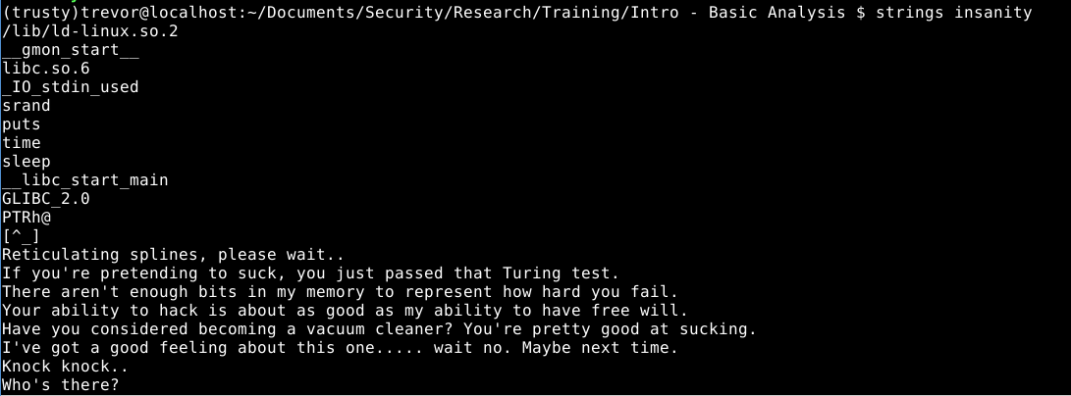

As you can see from the output, the strings command has given us, well, a whole bunch of strings. This output allows us to see possible functions this program uses during execution. Functions such as: srand(), puts(), time(), and sleep(). Try running the binary on your system to see if sleep() is actually used. The next pieces of data we can see are hard coded strings such as: “Reticulating splines, please wait..”, and “Knock Knock..”. Finally, you can see system level functions used in the program. A good example is “__libc_start_main” this function is responsible for calling main() in every program we use.

Sometimes though, flags, and other important data we can use as clues are simply revealed by strings. If we scroll down a ways we’ll find:

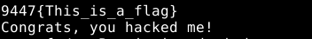

That’s our first flag in the bag! The strings command can often be combined with another command called [grep](http://www.cyberciti.biz/faq/howto-use-grep-command-in-linux-unix/) if you know beforehand what kind of information you’re looking for. Below is an example.

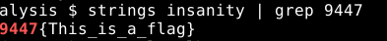

WhatAboutStrace

Introduction:WhatAboutStrace is an easy challenge designed to teach students additional steps to perform during a basic analysis against a target binary to learn more about the binary. Using the commands ‘strace’, and ‘ltrace’. These commands should be some of your first go-tos when trying to learn more about a target executable. This binary was originally written by the 9447 CTF team for their 2014 CTF competition.

Challenge: Learn how to use the command ’strace’, and ‘ltrace’, and retrieve the flag from the binary. The flag is how many seconds the sleep() function is called for in the form: TXSTCS{seconds}

Solving:The last two commands we’ll use during our basic analysis are ‘[strace](http://man7.org/linux/man-pages/man1/strace.1.html)’, and ‘[ltrace](http://man7.org/linux/man-pages/man1/ltrace.1.html)’. These two commands are helpful in determining a program's general behavior as it executes. Strace is a program that will print out every system call or signal a program makes or receives during its execution. Strace’s basic syntax is: “strace ./binaryToExecute”. Go ahead and run Strace against the insanity binary.

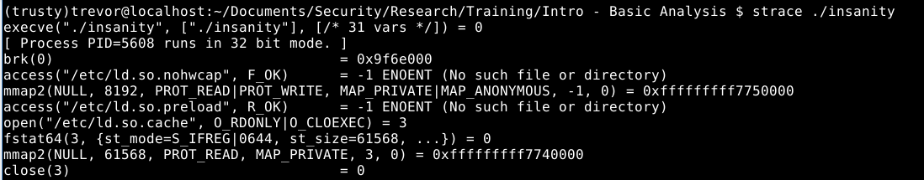

Each line output by Strace represents either a system call or signal received by the ‘insanity’ program during execution. For instance we can see calls to ‘[execve()](http://man7.org/linux/man-pages/man2/execve.2.html)’, ‘[open()](http://linux.die.net/man/2/open)’, and ‘[mmap2()](http://man7.org/linux/man-pages/man2/mmap2.2.html)’. Scroll down a little further in the output and you’ll see the system call to ‘[write()](http://linux.die.net/man/2/write)’ that is responsible for printing out “Reticulating Splines….” to the screen.

Finally let's take a look at the Ltrace command. Ltrace functions similarly to Strace with the minor difference that Ltrace prints out library calls made by a program during execution. Its syntax is: “ltrace ./binaryToExecute”. Run the command and you should see:

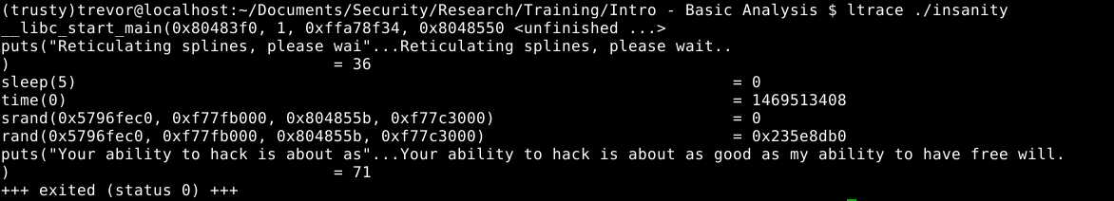

If you’ve executed the binary normally before you should recognize some of these calls. ‘[Sleep()](http://linux.die.net/man/3/sleep)’ is responsible for that boring 5 second delay before printing a message which is the value of the flag!. You can also see a call to the ‘[puts()](http://www.tutorialspoint.com/c_standard_library/c_function_puts.htm)’ function responsible for printing “Reticulating splines”. Finally we can see information we normally can’t; there’s a call to puts() which should print out “Your ability to hack is….” right before the program exits. Now while none of this information is particularly useful for this challenge. I wanted to demonstrate the power behind the Strace and Ltrace commands when learning about how to approach a target binary.

Flag: TXSTCS{5}

ILostThePassword

Introduction:ILostThePassword is an easy level challenge designed to teach students to perform basic reverse engineering analysis against a target binary. In this specific case we’ll be reversing the binary to find the password needed to retrieve the flag. This challenge was originally presented by the EKO CTF team during their Eko-Party-Pre-CTF competition hosted in 2015.

Task:Find the required password to retrieve the flag by disassembling the binary. There are many disassemblers out there, such as: [Hopper](https://www.hopperapp.com/), [GDB](https://www.gnu.org/software/gdb/), [IDA-Pro](https://www.hex-rays.com/products/ida/), [Immunity](https://www.immunityinc.com/products/debugger/), and [Radare2](http://radare.org/r/) just to name a few. There are also online debuggers, such as: [ODA](https://www.onlinedisassembler.com/odaweb/) and [Retargetable](https://retdec.com/decompilation/). Personally I would recommend using Hopper, it features an easy to use interface, and has all the features we will need for this challenge, and others under the demo version.

Solving:Today I’ll show you how to solve this challenge using [Hopper](https://www.hopperapp.com/). However, you’re free to use the disassembler of your choice. But first, let’s begin with a basic analysis.

Executing the ‘file’ command gives us the following information:

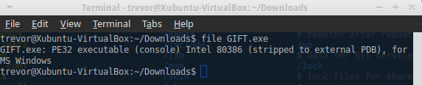

The binary we’ll be reversing today is a PE32 executable based on the [Intel 80386](https://en.wikipedia.org/wiki/Intel_80386) architecture for MS Windows, or in layman's terms an EXE which will run on Windows. Which means we’ll need access to a Windows machine if we want to run the binary.

Executing the ‘strings’ command gives us the following information:

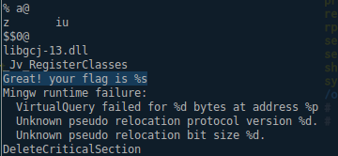

Above is a snippet containing the important information produced by the ‘strings’ command. The most important piece of info is highlighted: “Great! Your flag is %s”. Which means that string is somewhere in the program.

## Using Hopper:

Let’s begin by opening Hopper then loading the executable, the default settings should be just fine.

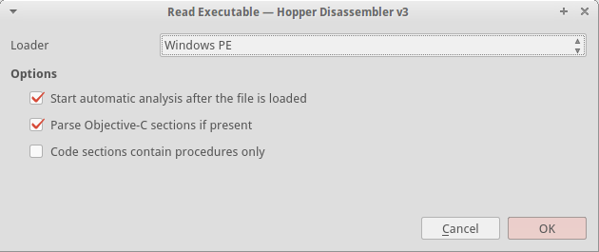

Once you click ‘OK’ hopper should disassemble the executable and drop us in at the Entry Point which is listed under the ‘labels’ tab. I said previously that the string “Great! Your flag is %s” would be a good starting point. Let’s see if we can’t find it inside of the executable. Switch over to the ‘strings’ tab in Hopper and you should see it. Click on the string and Hopper will jump to its reference in memory.

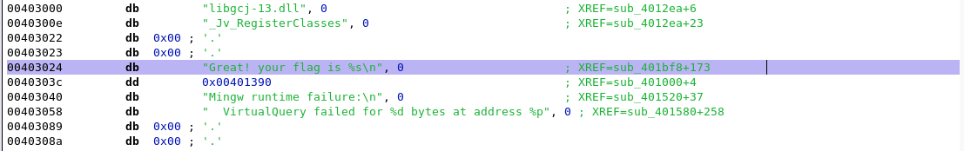

At address 0x00403024 you should see the string, off to the right you should see the information “XREF=sub_401bf8+173”. There are two pieces of information that line tells us. First, this string is referenced at function stub 401bf8. Functions in the disassembler are referred to as ‘sub_xxxxx’ which stands for subroutine. This is because when we compile a program the compiler doesn’t save user named functions. Second the ‘+173’ portion tells us the exact offset in the subroutine where the string is used.

Let’s navigate to sub_401bf8 by switching to the ‘labels’ tab in Hopper and clicking on the subroutine. Hopper should then jump to the beginning of the subroutine. If you followed those steps correctly your screen should look something like the following.

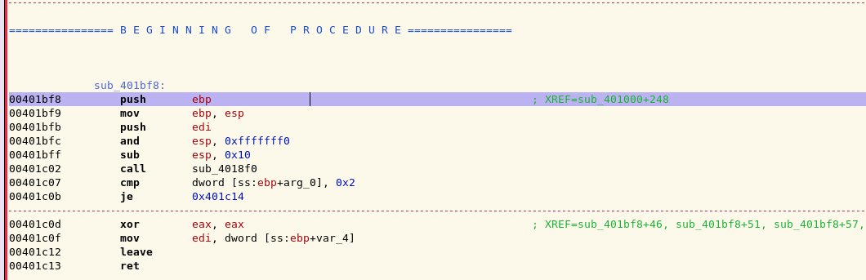

Now let’s try and find the string “Great! Your flag is %s” within this subroutine. Start by scrolling down through the subroutine, don’t worry about the particular instructions you’re scrolling past at the moment, I’ll explain those later. Around address 0x00401ca5 we’ll find what we’re looking for.

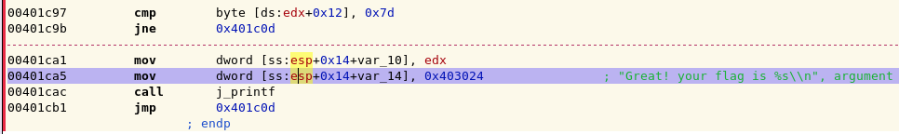

Good, we’ve found a function / subroutine that will print out the string “Great your flag is %s”, chances are this subroutine is responsible for printing the flag we need to pass the challenge, let’s get into the meat of this challenge. From the previous highlighted address begin to scroll up and look closely at the instructions being executed, you should notice a pattern.

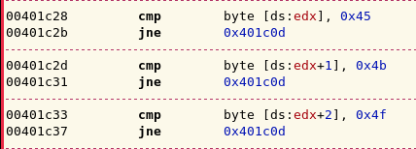

Hopefully you’ve noticed a large amount of ‘cmp’ instructions followed immediately by a ‘jne’ instruction. Let me break down what’s happening here. Basically, when the program executes the current subroutine each one of these ‘cmp’ (compare) instructions will be executed. If any one of the comparison returns false then the next ‘jne’ (jump not equal) instruction will be executed and

the program will stop executing the current subroutine and return to executing instructions elsewhere in the program.

To give a more concrete example let's examine the ‘cmp byte [ds:edx], 0x45’ instruction located at address 0x00401c28 from the previous screenshot. When this instruction is executed by the program a comparison will be made between the hardcoded value ‘0x45’ and whatever happens to be stored in the edx register. More likely than not the edx register contains user input. If the comparison returns false then the jne (jump not equal) instruction located directly after the compare will be executed and the program will leave the current subroutine.

Here’s the most important part though. We can see the exact values our input is being compared against. ‘0x45’ is hexadecimal for the ASCII character ‘E’, ‘0x4b’ corresponds to the ASCII character ‘K’. Let’s start at the very first compare and convert the hexadecimal values to ASCII and see what the final result is.

I’ve compiled a table below omitting the ‘0x’ portion of hexadecimal to save space:

[45, 4b, 4f, 7b, 74, 68, 69, 73, 5f, 69, 73, 5f, 61, 5f, 67, 69, 66, 74, 7d]

Now let’s use an online hexadecimal to ASCII conversion [website](http://www.rapidtables.com/convert/number/hex-to-ascii.htm) to convert the values. The output is below:

Flag: EKO{this_is_a_gift}

Congratulations, you’ve successfully reversed your first binary.

BypassingChecks

Introduction:BypassingChecks is a medium level reversing challenge designed to improve students reverse engineering skills by learning to bypass simple checks found in binaries. Learning to bypass simple checks is useful because you can then control the execution flow of a program without actually meeting those requirements. This write-up assumes you have basic knowledge with the debugger and disassembler of your choice. This challenge was originally presented during the ‘school-ctf-winter-2015’ competition under the same ‘simple-check-100’

Task: Using the debugger and disassembler of your choice, bypass the simple check in the binary to retrieve the flag.

Solving:This write-up will be solved using GDB Debugger and Hopper disassembler, but you’re free to use whatever tools you’re comfortable with. Let’s begin by performing a basic analysis against the binary using the ‘file’ and ‘strings’ command.

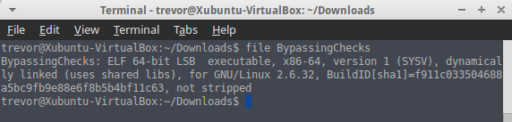

There are two pieces of information that are important at the moment. First, this file is a 64-bit elf binary. This means that file is executable, and it was compiled on a Linux system. Second, this binary is ‘not stripped’ meaning this binary was compiled with debugging info enabled “gcc source.cpp -g”. Compiling binaries with debugging info enabled allows you to read high level code inside of the debugger / disassembler. The alternate is a ‘stripped’ binary that wasn’t compiled with debugging information.

This means we would only be able to read assembly / machine code in the debugger / disassembler. Next let’s take a look at the output from the strings command.

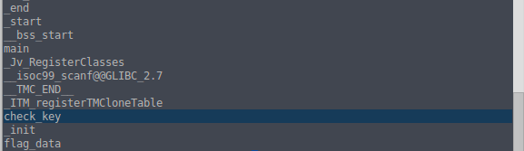

The above screenshot is only a partial output. The majority of the output produced by strings is rather uninteresting but I’ve gone ahead and highlighted what could be an important piece of information later. Notice that there’s two strings somewhere in this binary named ‘check_key’ and ‘flag_data’. It’s possible those two strings could be of use later when you begin reversing the binary.

Finally, finish the basic analysis by executing the binary and seeing what this program does. First you’ll need to chmod the binary so you can execute it on your system ‘chmod 755 binaryName’. Upon execution the program asks for us to input a key. I tried ‘12345’ the program then output “Wrong” and quit. Trying several other inputs resulted in the same behavior. It becomes pretty clear you need to figure out the magic key, or bypass the check that compares your key with the correct key.

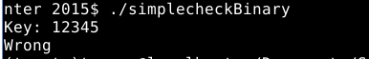

Go ahead and open up your disassembler of choice and let’s get to reversing this binary. The default options for disassembling the binary should work without any problems.

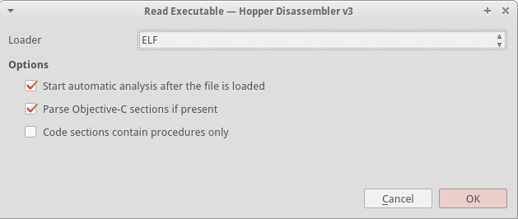

Let’s start by taking a look at main() to try and figure out what this executable is doing. I’ll also highlight a very useful feature of Hopper, although I believe IDA-Pro and Radare2 have similar functionalities. Below is a snippet from main()

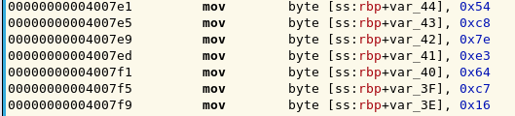

It seems as though one of the first things main() performs when the program is executed is to move a large chunk of hexadecimal characters onto the stack. This could quite possibly be the program generating the flag for us. Use a Hex to ASCII converter to find out for yourself!

All of this assembly gets a tad tedious to deal with though doesn’t it? Let’s have Hopper do some heavy lifting for us and generate some high level pseudo code for the main() function.

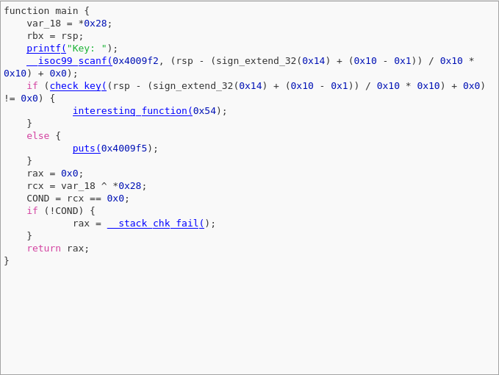

That’s much better! Using the pseudo code generated by Hopper it’s much easier to get a better understanding of a program's functionality. In this case the main() function executes a printf() statement that outputs “Key:” to the screen, then takes our user input via a call to scanf(). Once user input is read a conditional if() calls check_key() to validate our input against the correct key. If check_key() returns anything other than 0 interesting_function() will be executed. Otherwise a simple puts() function is executed. I’m going to go out on a limb and say that puts() function is responsible for printing “Wrong!” to the screen.

Since we now know there’s a function responsible for validating our input, let’s take a look at the function and see if we can’t figure out how our input is validated. Below is pseudo code generated by Hopper for the check_key() function.

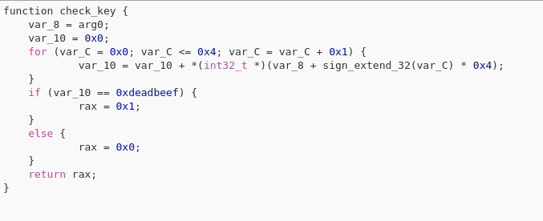

Inside of the check_key() function two variables are created, var_8 and var_10. Then the program enters a for() loop which appears to take the data from var_8 and place it into var_10. Next the program enters a conditional if() statement which compares the data in var_10 to 0xdeadbeef. If this comparison returns true the value of the $rax register is set to 1, otherwise the $rax register is set to 0. Then the function returns the value of the $rax register. For instructional purposes I’ve segmented the assembly instructions below.

For Loop:

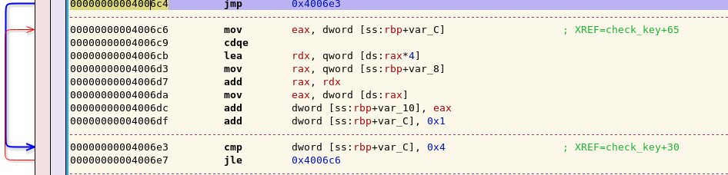

If Statement:

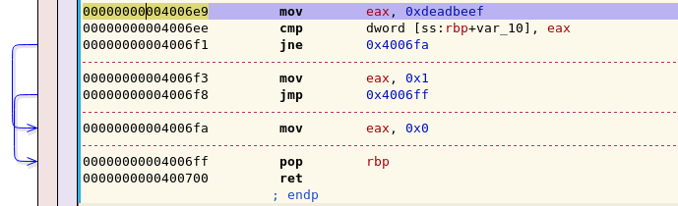

It should be clear now that your input needs to evaluate true against 0xdeadbeef to get the proper return value from the check_key() function. However, 0xdeadbeef is a [magic number in hexspeak](https://en.wikipedia.org/wiki/Hexspeak) for an uninitialized segment of memory. This means there isn’t a valid key to compare your input against, so no matter what you enter the program will never give us the flag.

But there’s still hope! Hypothetically if you did input the correct key the value of $rax register would be set to a value of 1 to indicate the correct key was input by the user. Why don’t you use GDB to set a breakpoint at the address 0x400700 right before the function returns and set the value of $rax to 1 manually? Try it out.

Open the binary in GDB by typing ‘gdb ./binarytoexecute’ in the command line.

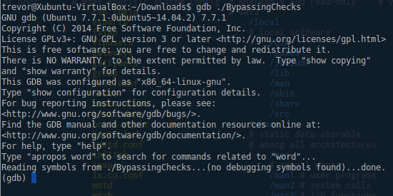

Next you want to set a breakpoint at address 0x400700 to pause the execution of the program right before the check_key() function returns. This is done so you can set the value of $rax to 1 before the function returns. Setting a breakpoint is as easy as running ‘break *0xADDRESS’ inside of GDB

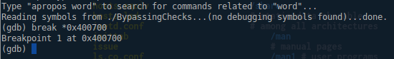

Then you want to run the program inside of GDB so the breakpoint we just set is hit. Type ‘run’ inside of GDB to execute a program. The program will execute as it normally would outside of GDB until we hit our breakpoint.

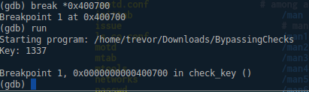

Finally, before you continue the program's execution you want to set the value stored in the $rax register to 1. Faking the program into thinking you entered a valid key. You can manually set the value stored inside a register with the command ‘set $register = value’. Additionally, you can inspect the current value stored in a register with the command ‘i r register’ where ‘i’ stands for inspect, and ‘r’ for register.

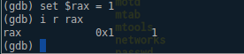

After you’ve set the value contained in the $rax register to 1 you’re free to continue the programs execution by typing ‘c’ or ‘continue’.

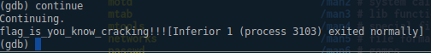

Flag: TXSTCS{flag_is_you_know_cracking!!!}

Congratulations, you now know how to bypass simple checks found inside of binaries to control the execution flow inside of a program.

LD_PRELOAD

Introduction:LD_PRELOAD is a medium level reversing challenge designed to improve students reverse engineering skills by teaching what’s commonly referred to as the “LD_Preload” trick. Which will allow you to heavily influence the way a program executes. This problem was originally presented during the ‘Hit In The Box’ CTF hosted in 2014.

Task: Using the LD_Preload trick, and the disassembler / debugger of your choice retrieve the flag from the provided binary.

Solving:This write-up will be solved using GDB Debugger and Hopper disassembler, alongside the LD_Preload trick but you’re free to use whatever tools you’re comfortable with. Let’s begin by performing a basic analysis against the binary using the ‘file’ and ‘strings’ command.

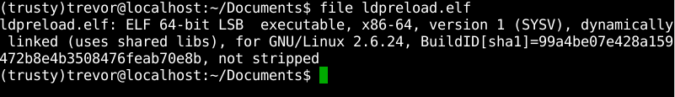

Nothing out of the ordinary here. I’ve omitted the output from strings because it was largely uninteresting other than a string that said “OK YOU WIN HERE’S YOUR FLAG!” with no output after that.

Let’s move on to executing the program to see what happens, remember to chmod the binary if need be.

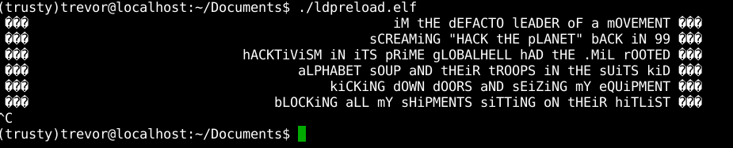

All this program seems to do is output some song lyrics, if you wait long enough the program loops and continues repeating the lyrics. Also, am I crazy or is the delay between each output getting longer as the program executes?

Let’s take a look at the output from both strace and ltrace and see what calls and libraries this program is using. Maybe that will give us a better idea of what’s happening here. The output from strace is first, ltrace second. Both screenshots are trimmed due to repeated behavior between lyrics.

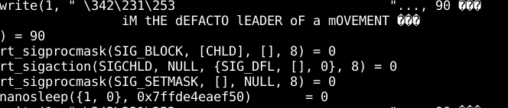

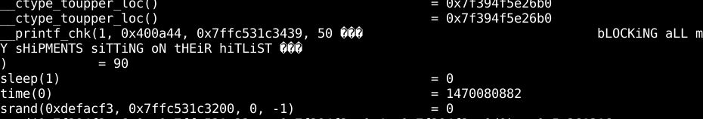

Between each lyric output the program makes a call to the c functions sleep() and time(). Calls to these functions are responsible for the pause between each lyric output. Now that we have a better picture of how this program executes let's open the program in the disassembler of your choice and see if we don’t notice any glaring items.

Inside of hopper there are two strings of interest, the first is “OK YOU WIN. HERE’S YOUR FLAG:” and the “Key: “ string. The first string is located at address 0x40081f, and the second at address 0x4007e8. I’ve put the assembly instructions provided by Hopper below.

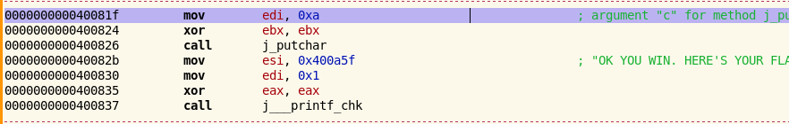

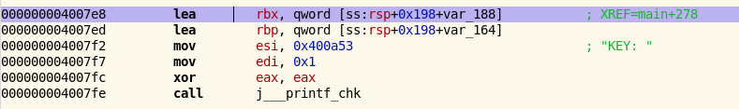

Open up the debugger of your choice and try jumping to those addresses manually and see what happens!

Hopefully you noticed that if you try to jump to the addresses the outputted flag is still garbage when we jump to 0x4007E8. Jumping to 0x400803 immediately segfaults. Not what we want. It was a longshot but it was worth the try.

Now it’s time to get into the meat of this challenge. What if you could fake both the sleep calls and elapsed time, tricking the program into thinking it has actually slept for the required number of seconds? You can do that by overriding GLIBC’s sleep() and time() functions very easily: create a C file that contains the functions you want to override, and make them have the same signature. Just increment the time with one second on every sleep() call, without invoking the underlying sleep() function. Then compile it into a shared object and preload it using the [LD_PRELOAD trick](https://rafalcieslak.wordpress.com/2013/04/02/dynamic-linker-tricks-using-ld_preload-to-cheat-inject-features-and-investigate-programs/). When you’d run the binary, the sleep function will execute our implementation, while it still increases the elapsed time.

What we need to do now is write our own implementations of time() and sleep() to achieve this desired effect. To save time I’ve attached a copy of the code, it is also presented in the screenshot below.

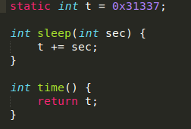

Now all that’s left to do is compile this piece of code into a shared object ‘gcc -fpic -shared -o time.so time.c’ and execute the binary with LD_Preload! ‘LD_PRELOAD=./time.so ./ldpreload-patched’

I’ve provided a patched binary that doesn’t print out the song lyrics because that takes time. If you would like to test the LD_Preload trick against the original binary you’re more than welcome to, it’ll just take some time to print every iteration of the lyrics.

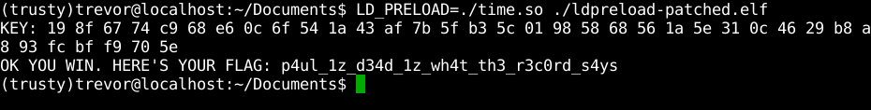

Flag: TXSTCS{p4ul_1z_d34d_1z_wh4t_th3_r3c0rd_s4ys}

Congratulations! You now know how to use the LD_Preload trick!

AndroidRE

Introduction:AndroidRE is designed to introduce students to the basics of reverse engineering a very simple Android application. This challenge centers mostly around basic decompilation of APK files using a tool known as jadx followed by reading the decompiled Java code. This problem was originally presented during the ‘Ice CTF’ hosted in 2015 under the name ‘husavik’.

Challenege: Decompile the provided APK using the provided tool, and find the flag hidden in the code.

Solving:Download both the provided tools and the ReverseMe.apk file provided in the challenge package. You’ll notice inside of the tools archive I’ve provided two tools, APKTool, and the aforementioned Jadx tool. You can solve this problem using either tool, however I’ll be using Jadx due to the simple GUI interface provided. However, if you wish to use APKTool decompilation of an APK file is as easy as executing the following command: ‘apktool -d PATHTOAPK’

So first things first here, go ahead and launch Jadx - Gui. Decompile the provided APK by going to file->openfile->reverseme.apk. After you specify the APK to decompile Jadx will list the decompiled packages in the left-hand side of the interface seen below.

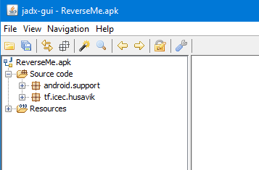

You should see two folders named, “Source code” and “Resources”. The first stop we should make when reversing any APK is to take a look at a file called “AndroidManifest.xml”, located under the “Resources” folder. Every Android application is required to have one of these manifest files. The manifest file contains important information required by the Android system to run the application, details such as:

* the java package for the application, which uniquely identifies the application
* Descriptions of the components used by the application, the activities, services, broadcast receivers, and content providers that the application is composed of, as well as the permissions the application needs access to.

The complete details of the information contained inside of the manifest file can be found on Google’s developer page [here](https://developer.android.com/guide/topics/manifest/manifest-intro.html). A screenshot of this application's manifest file is below:

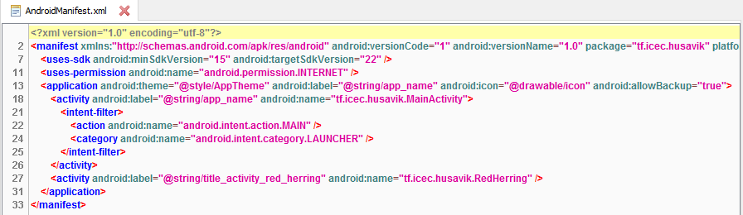

By examining the manifest file, we can learn several key pieces of information. This application’s main package is “tf.icec.husavik”, this application requires internet privileges, and finally this application's main activity while running is contained in “tf.icec.husavik.MainActivity”.

Let’s shift gears now and see if we can’t find any interesting information contained in the main package “tf.icec.husavik”. This package is contained under the “Source code” tab go ahead and open it up to list the contents of the package.

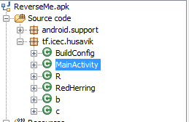

We can see from the contents of the main package that this is a relatively simple program. Think of the MainActivity class as you would a main() function in a c++ program. While every other class file could be seen similarly to their c++ counterpart if that makes sense. Our next step should be to take a look at the code executed in MainActivity for clues.

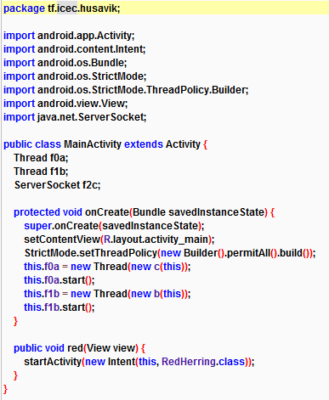

Above is a screenshot of the MainActivity class. There’s a few things to be learned by examining this code, I’ll list them out from top to bottom. First, notice that two Thread variables are created, as well as a ServerSocket variable. The declaration of those variables could indicate that at some point this application could execute additional behavior in a secondary thread while the main application continues to run. Additionally, the ServerSocket variable could be used for some form of internet communication.

After the variable declarations the first few lines of code simply draw the applications interface to the screen. This snippet of code below is interesting though.

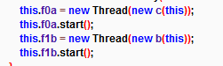

When these lines of code are executed by the application new threads will be created and the activity defined in classes ‘c’ and ‘b’ will be executed. Let’s go take a look at those classes and see if we can’t learn what’s going on.

Let’s analyze the behavior of class ‘c’ the code is below.

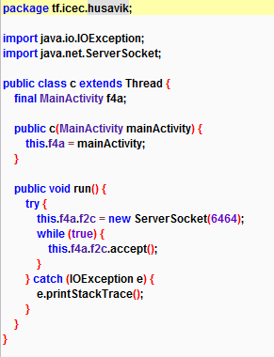

The only real functionality class ‘c’ provides is opening a socket on port 6464 and accepting incoming connections while the thread remains active. Let’s take a look at class ‘b’ now and hope we find something worthwhile, code snippet below.

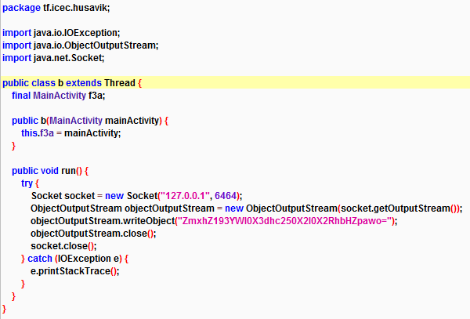

At first glance it seems class ‘b’ provides similar functionality to that of class ‘c’. Class ‘b’ opens a socket on port 6464 using the localhost IP address 127.0.0.1. After the socket is created the application uses an objectOutputStream to write a base64 encoded string object to the socket. I wonder what the application’s trying to write. Let’s use an online base64 decoder to find out.

Decoding the base64 string reveals: flag_wait_wasnt_it_dalvik

Flag: TXSTCS{flag_wait_wasnt_it_dalvik}

Congratulations, you’ve officially reversed your first Android binary. I strongly suggest you poke around the other files in the decompiled binary to learn a little more.

# Intro to Exploitation:

FormatStrings

Introduction:FormatStrings is an easy exploitation challenge designed to teach students about basic format string vulnerabilities. Format string vulnerabilities allow attackers to read or write values to specific addresses specified by the attacker. This vulnerability arises when a programmer doesn’t properly pass input into a format function such as printf(). There’s an excellent write-up on format string vulnerabilities located over at [CodeArcana](http://codearcana.com/posts/2013/05/02/introduction-to-format-string-exploits.html) which dives into more detail then I’m going to cover here. I will however explain the basics. This problem was originally presented during the 2015 ‘Ice CTF’ under the name ‘fermat’

Printf() and by extension other format functions can accept a variable length of parameters, assume the following as an example. If I had a printf() statement containing printf(“This is a format string, and specifies what is to be output. Here are some numbers %d %d %d”, 1, 3, 5). When executed the previous statement would output: “This is a format string, and specifies what is to be output. Here are some numbers 1 3 5”. In the case where the programmer specifies exactly what is to be output by printf() there exists no format string vulnerability. But what happens if the programmer writes something like, printf(user_input)? Since printf could have variable number of arguments, printf() must use the format string provided by the programmer or passed by the user to determine the number of arguments. In the case above, an attacker can pass the string "%x %x %x %x %x %x %x %x %x %x %x %x %x %x %x" and fool the printf into thinking it has 15 arguments. Printf() will then naively print the next 15 addresses on the stack, thinking they are its arguments.

|  |  |  |
| --- | --- | --- |
| **Format String** | **Output** | **Usage** |
| %d | Decimal Numbers (Ints) | Outputs decimal numbers |
| %s | Character Strings | Reads strings from memory |
| %x | Hexadecimal Addresses | Output hexadecimal address |
| %n | Number of bytes written so far | Writes the number of bytes till the format string to memory |

There are 3 basic steps to exploiting any format string vulnerability.

1. Determine if the program is contains a format string vulnerability
2. Find the address you wish to read or write to on the stack
3. Exploit the vulnerability

Enough talk for now, let’s get into the challenge.

Challenge:The provided code and binary is vulnerable to format string exploits can you modify the ‘secret’ variable to pass the comparison and launch a shell to read the flag contained on the remote server? I’ve provided the relevant code snippet below.

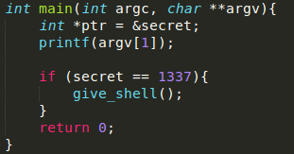

Solving: Let’s begin by verifying this program is in fact vulnerable to format string exploits. This is done by passing either of the following format string specifiers: ‘%x’, ‘%p’. The first format specifier %p tells printf() to print out a pointer. The second format specifier %x tells printf() to print out a hexadecimal number.

The way I prefer to test for format string vulnerabilities is as follows: ./programToRun ‘AAAA%x %x %x %x %x %x %x….’

The AAAA portion of the string allows me to keep a reference of where we are on the stack once we start reading values. There are ‘....’s following the %x’s to indicate I can use as many, or as few %x arguments as a like. Let’s go ahead and give it a shot.



This program is in fact vulnerable to format string exploits. When I passed the string ‘AAAA%x %x %x %x’ the program printed out ‘AAAA’ correctly and then proceeded to print out the addresses: 0xffad1434, 0xffad1440, 0xf755a4ad, and 0xf76d23c4 off of the stack.

Now that we know this program is vulnerable it’s time to find the address of the ‘secret’ variable on the stack. To do this we can use the ‘objdump’ command as follows: ‘objdump -t PROGRAMTORUN | grep VARIABLE’.

In our case the proper usage would be: ‘objdump -t FormatStrings | grep secret’



The output of objdump tells us that the variable ‘secret’ is located at the address 0x0804a02c. Using the format string vulnerability we now need to find where the address 0x0804a02c is located on the stack when the program executes. Repeat the above process to dump addresses by passing a variable length of either %x or %p until you find the address on the stack.

In the example below I pass my ‘AAAA’ string followed by 10 %x format specifiers.

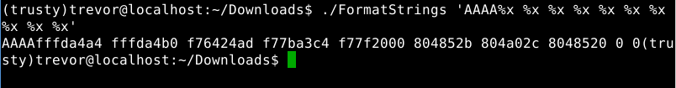

When I executed my format string much like last time the program output the ‘AAAA’ segment followed by addresses as they were pulled from the stack, the addresses read are as follows: 0xfffda4a4, 0xfffda4b0, 0xf7643ad, 0xf77ba3c4, 0xf77f2000, 0x804852b, 0x804a02c, and 0x8048520. The last two ‘0’, ‘0’ numbers are non-valid addresses.

So what does this tell us? If you remember above the variable ‘secret’ is stored at address 0x0804a02c. The seventh address printed by our format string corresponds to the address of the variable secret. This tells us that the variable secret is stored at the seventh address on the stack. Using this piece of information, we now know we need to write the needed value to bypass the conditional statement to the seventh address on the stack.

We can accomplish this by using another handy format specifier in conjunction with our format string. The ‘%#$x’ or ‘%#$p’ format specifier where ‘#’ is the position of the variable you’re trying to read / write on the stack allows us to specify the exact position on the stack we would like to read or write to. An example is below.



I passed ‘AAAA %7$p’ to the program and printf() output my ‘AAAA’ as well as the seventh argument on the stack as specified.

Now all that’s left to do is modify the value stored in the address corresponding to the variable ‘secret’ so we can pass the conditional statement. Luckily printf() has a very odd format string specifier ‘%n’. This format specifier means:

“*The number of characters written so far is stored into the integer indicated by the int * (or variant) pointer argument. No argument is converted.”*

This means if we were to pass the string ‘AAAA%7$n’ we would write the decimal value 4 (each char is one byte) to the address containing our secret value. Using this trick we can write any value we wish to the address that contains our secret variable. However, it seems like we would have to print an exorbitant amount of characters to write the needed value.

Fortunately, we can bypass this pesky requirement by using a width specifier in our format string. if we pass ‘AAAA%100x’ to the program, 104 characters will be output. This is because %100x prints the argument padded to at least 100 characters. Therefore, we could do the following ‘AAAA%<value-4>x%7$n’ to write an arbitrary value to the address 0x0804902c.

The only thing left to do now is execute our final format string. What’s the value we need to write again to pass the conditional statement?

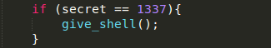

Oh right, 1337. We need to write 1337 into the address 0x0804902c. Let’s give it a shot.

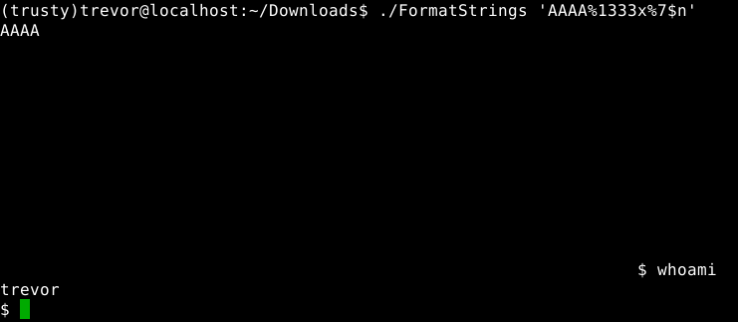

Bingo! We’ve successfully written the desired value of 1337 into the variable containing ‘secret’ using a format string exploit and launched a new shell environment.

What if all of that was a little too much work though? Thankfully there’s a very nice tool called FormatStringExploiter we can use that will exploit format string vulnerabilities for us, and I’m going to show you how to use it! I’ve included the tool with the challenge package.

You too can be a 31337 hacker in 7 easy steps.

1. Using Objdump find the address of the variable you wish to read or write to.   
   
2. Launch the tool, specify the number of variables you would like to read off of the stack. The tool will provide you with a generated format string to pass to the target program.   
   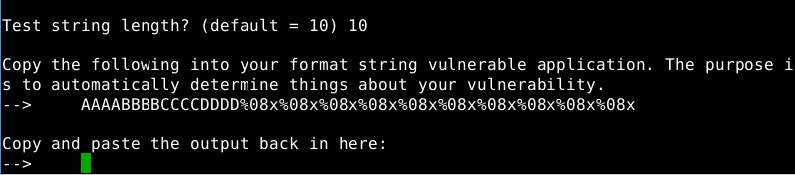
3. Pass the generated format string to the target program, copy the output from the target program and paste the output from the target program back into the tool as requested.   
   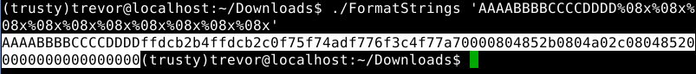  
   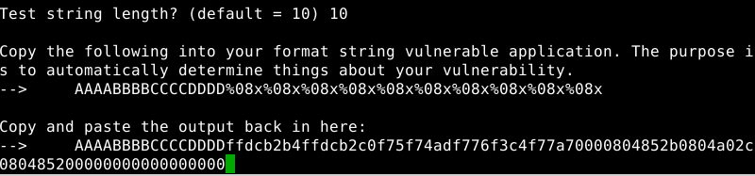
4. The tool will then output its findings based on the output of your target program. Then you will be prompted if you wish to perform an arbitrary read, or arbitrary write. Even though the tool reports no control points found we already know the address of the variable we want to write to.   
   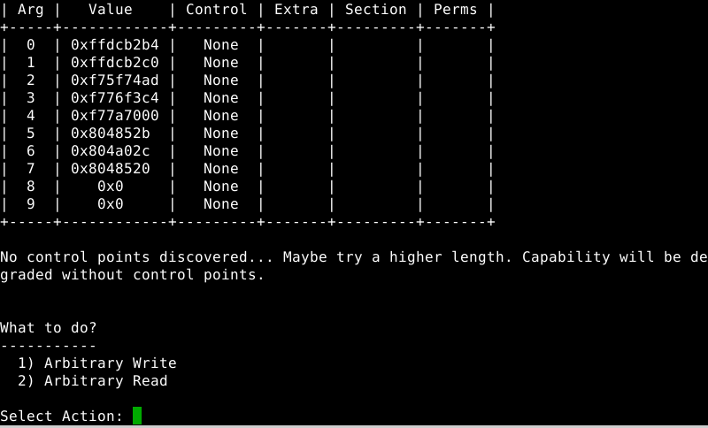
5. Select the option your wish, pass the address, and the value you want to write  
   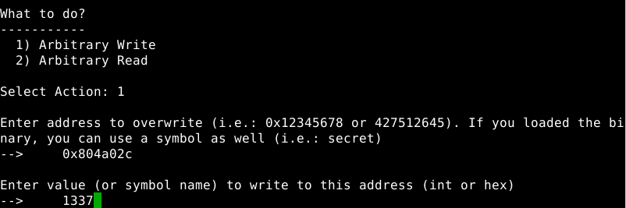
6. Paste the generated payload into your target program  
   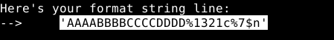  
   

1. Profit.

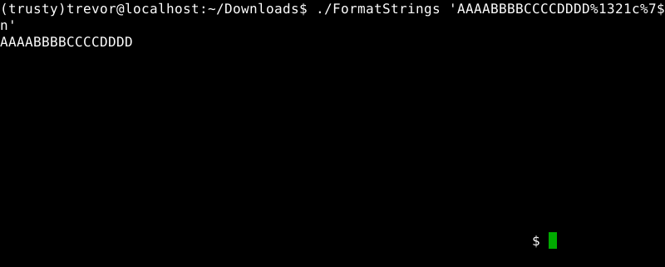

SimpleOverflow

Introduction:SimpleOverflow is an easy level exploitation challenge intended to introduce students to the concept of buffer overflow exploits; As well as the potential dangers involved with not verifying the size of a user's input against the size of the buffer that input will be stored in. Buffer overflow exploits also can potentially allow an attacker to execute arbitrary code, modify values of variables within a program, or jump to functions within a program that are otherwise not executed.

Challenge: The provided program is vulnerable to a buffer overflow exploit. Modify the value stored in the ‘secret’ variable to the required value to execute the give_shell() function by executing a buffer overflow to retrieve the flag.

Hints:[**Wikipedia knows about buffer overflows, do you?**](https://en.wikipedia.org/wiki/Buffer_overflow)

Solving:Buffer overflow refers to any case in which a program writes beyond the end of memory allocated for any buffer. For example, if you have a program that can only store 250 characters of user input but the user is allowed to enter a 300-character string the program is vulnerable to a buffer overflow exploit. The extra 50 characters entered by the user will begin to overwrite adjacent memory values outside of the buffer.

In this challenge you are given access to a shell with standard user privileges (not root). You are expected to execute a buffer overflow against the running program and gain root privileges to retrieve the flag on the remote server. This write-up will execute the binary locally, but the steps are still the same.

Let’s begin by analyzing ‘overflow.c’ and find the vulnerability in the program.

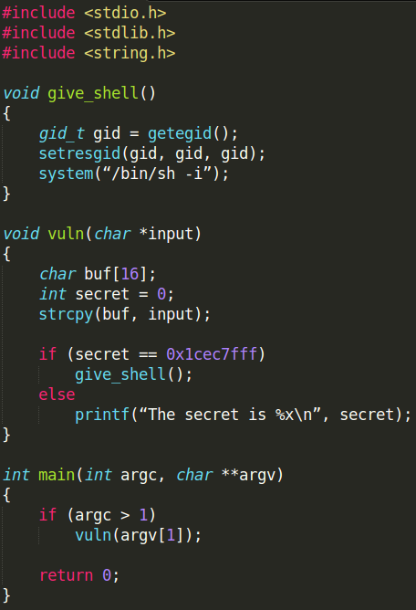

We can see from the above source code that the main function of the program calls vuln() with the second command line argument (argv[1]) as a parameter. The vuln() function contains a character buffer of length 16 bytes (char buf[16]) which is allocated on the stack when the function is called. There is also an integer value (int secret = 0) allocated on the stack directly after the character buffer. Finally there is a call to a vulnerable function strcpy() (aka: string copy). Strcpy() function is responsible for copying our input into the 16 byte buffer on the stack. This function is vulnerable because it does not have any form of bounds checking. Meaning we could provide input larger than 16 bytes and the program will not raise an exception.

When we provide an input larger than 16 bytes everything beyond the 16 bytes will begin to overwrite memory values adjacent to the buffer on the stack. Since the integer variable ‘secret’ is declared directly after the ‘buf[16]’ variable these two variables are adjacent to each other on the stack. Therefore the first thing overwritten when our buffer overflows is the value contained by ‘secret’.

Let me show you using GDB. For illustrative purposes I’m also going to modify the initial value in the secret variable to the integer 1337. However, I will change the initial value back to 0 before we begin exploiting the program. Compile the program using the following command ‘gcc -m32 source.c -o outfilename  execstack-fno-stack-protector -g -O0’

Once the program is compiled open the program inside of the GDB Debugger, I prefer to use the text UI myself ‘gdb -tui ./programToExecute’. Inside of GDB you can navigate the text UI pane by using either the arrow keys, or the page up / page down keys. During the program's execution it would be nice to halt the program at certain points to monitor our input on the stack.

This is achieved by setting a ‘breakpoint’ at a desired line of code ‘b LineofCode’ or an address of a specific assembly instruction ‘b *0xADDRESS’ inside of GDB. Since we’re interesting in seeing our input on the stack as well as the secret value we want to set a breakpoint directly after the strcpy() instruction is executed. Personally, I also like to put a breakpoint on main() so the program halts immediately following execution ‘b main’

In total I have three breakpoints, one at main, line 16, and line 17. As shown below.

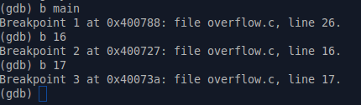

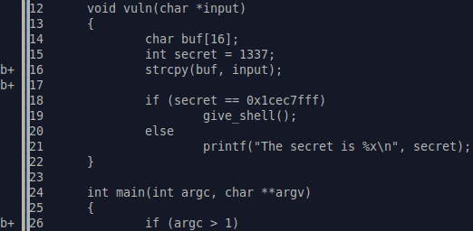

Once the breakpoints are set we can go ahead and execute the program inside of GDB. To do this we type the command ‘run’ combined with some input since the program does take our input after all. The actual command should look something like: ‘run ThisIsMyInput’. However, I will be using python to pass my input to the program using python to pass input makes sending larger inputs to programs very easy, it’s also very easy to use.

Additionally, I don’t want to just send any random 8-character string into the program. It’s smart to use input that is easily identifiable on the stack. For example, the ASCII character ‘A’ when placed on the stack is represented by the value ‘41’ passing 8 ‘A’ characters will make identifying our input on the stack very easy.

Execute the program in gdb using the following command: ‘run $(python -c ‘print “A” * 8’)’. When the program begins execution you will hit the breakpoint set at main immediately. You can continue execution of the program a single instruction at a time using the ‘step’ command. You can also continue execution until the next breakpoint is hit by using the ‘continue’ command. I’ll be using the ladder here.

Continue the program execution until you hit your last breakpoint at line 17.

Once the program pauses execution at breakpoint 17 it’s time to examine the contents of the stack. This can be done by using the following command: ‘x/20xg $esp’. This command stands for “Examine 20 large words starting at the address pointed to by $esp”. $esp is a special register in the processor responsible for keeping track of the top of the current stack. The contents of the stack is below.

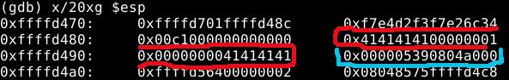

From the screenshot above we can see the stack begins at address ‘0xfffd470’. The 8 ‘A’s we passed to the program as input begin at address ‘0xffffd480’ and are outlined in red. Finally, the value of secret is outlined in blue. Since data and addresses are stored on the stack in hexadecimal value the decimal value 1337 becomes ‘0x539’ you can use a simple online calculator to confirm this.

Now that we’re familiar with how our input is stored on the stack. Let’s see what happens when we pass an input that is bigger than 8 bytes. Let’s try an input of 16 bytes. Repeat the previous steps using an input that is 16 bytes long and examine the contents of the stack. There’s no need to restart GDB or anything like that, just type the run command again and GDB will ask if you wish to restart the program.

‘Run $(python -c ‘print “A” * 16’)’

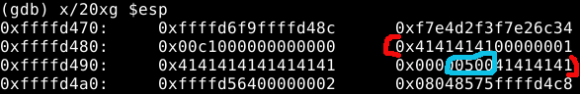

Interesting, it seems we’ve managed to modify the original ‘539’ value to ‘500’, which is good. This means we’re on the right track to exploiting this executable. Next, let’s try to pass two more additional ‘A’ characters with our input. This will bring our total input size up to 18 bytes, beyond what our buffer can hold.

‘Run $(python -c ‘print “A” * 18’)’

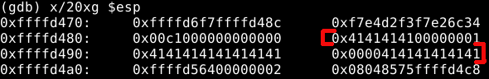

After passing 18 bytes of input to the program, it seems we’ve completely overwritten the value stored in the address previously. Let’s see what happens if we continue to run the program like this.

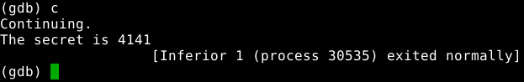

Perfect! We’ve successfully managed to overwrite the value of ‘secret’ with our input, exactly what we need. Now all we need to do is change the value of secret by passing the required value with our overflow. Looking at the programs code again the value of secret needs to be equal to ‘0x1cec7fff’ to execute the give_shell() function.

The last piece of information you must know to complete this exploit is that hexadecimal values are placed on the stack in little endian order, in other words backwards. Thus, we can overflow buf with 16 bytes and add 0x1cec7fff in little-endian to the end of our input. Thus, buf[16] will be set, and the remaining 4 bytes of 0x1cec7fff will be set to secret. In the end, this is our final payload:

‘Run $(python -c ‘print “A” * 16 + “\xff\x7f\xec\x1c”’)’

Run the program one last time in GDB and see what happens!

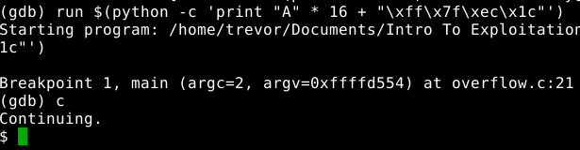

Prefect! If you successfully executed the exploit in GDB you should notice GDB seems to lock up and present us a ‘$’. This is because our original program executed a new program, a bash shell!

Quit out of GDB and run the exploit against the program outside of GDB with the same payload as before. You may have to close your terminal session if you are unable to break out of GDB with the ‘CTRL + C’ command.

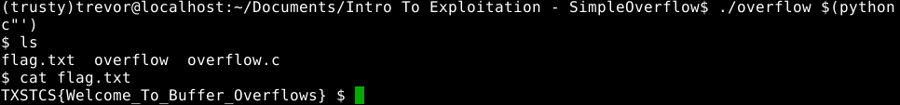

Congratulations, you now know how to execute simple buffer overflows.

## Flag: TXSTCS{Welcome_to_Buffer_Overflows}

Smash

Introduction:Smash is a medium level exploitation challenge intended to improve students’ knowledge and understanding of buffer overflow exploits and the potential dangers involved with not verifying the size of a user's input against the size of the buffer that input will be stored in. Buffer overflow exploits also can potentially allow an attacker to execute arbitrary code, modify values of variables within a program, or jump to functions within a program that are otherwise not executed.

Challenge: The provided program is vulnerable to a buffer overflow exploit. Execute a buffer overflow and jump to the flag() function to retrieve the flag. This task requires you to have basic GDB knowledge.

Solving:Buffer overflow refers to any case in which a program writes beyond the end of memory allocated for any buffer. For example, if you have a program that can only store 256 characters of user input but the user is allowed to enter a 300-character string the program is vulnerable to a buffer overflow exploit.

Executing a basic buffer overflow exploit usually consists of roughly three or so steps.

1. Trigger the overflow
2. Control the Return Instruction Pointer (AKA: $rip)
3. Jump to the user controlled buffer
4. Execute arbitrary code (if applicable)

Today we won’t be executing any arbitrary code, but simply causing the program to execute a function that otherwise isn’t called within the program.

I placed both a copy of the program’s source code, and a pre-compiled binary for your use. However, you’re free to compile your own binary. The proper way to compile a binary so it’s vulnerable to basic buffer overflow exploits is: ‘gcc -m64 source.c -o outfilename -z execstack -fno-stack-protector -g’ this will compile the program without any basic protection against these exploits.

If you are testing this exploit locally you will also need to temporarily disable Address Space Layout Randomization protection. On a Ubuntu based machine This can be done with the following command: ‘echo 0 | sudo tee /proc/sys/kernel/randomize_va_space’. ASLR protection will automatically be re enabled on your system following a reboot.

Finally, please note that the addresses given to you by gdb on your machine may differ from the addresses in the screenshots. Understand though that the process is still the same. Let’s begin!

First thing’s first, let’s examine the provided source code and learn what exactly makes this program vulnerable to a buffer overflow exploit.

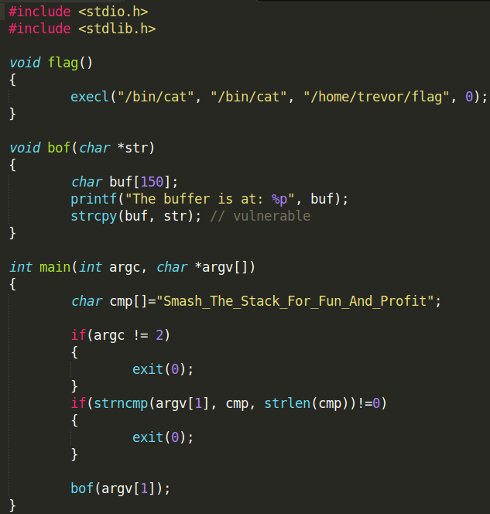

The program itself is very simple. Upon execution the program checks to see if two or more command line arguments are passed, and also checks to see if the second argument begins with the string “Smash_The_Stack_For_Fun_And_Profit”. If these conditions are met the program will call the bof() function, passing the user's input to the function. Otherwise the program will exit.

When the bof() function is called the input passed to the function is copied via the strcpy() function to a buffer that can contain up to 150 characters. If you notice there is no check to ensure that the user’s input will fit within the buffer. Due to this missing check, this program is vulnerable to buffer overflow exploits.

Finally, there’s a flag function that’s never called. Let’s see if we can’t change that.

Go ahead and open up the binary in the GDB Debugger. One of the first things we can do is find the address of the flag() function within the program. We’ll need this address to jump to it later. You can find the address of any variable or function within a program by using the command ‘info address functionName’ or ‘info address variableName’.

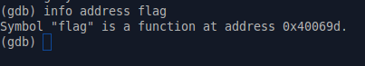

GDB happily reports that the flag function is located at address ‘0x40069d’ within the program. Make note of this address, you will need it later. The next step in this process is to verify that our target program is in fact vulnerable to a buffer overflow by providing input to the program that incredibly large. The easiest way to do this is to send an incredibly large amount of characters to the program. Normally you would manually have to type large inputs to the program. However, with some Python magic we can simplify this process.

Remember that the input passed must begin with the string mentioned above. Afterwards you’re free to send the program whatever you like. Most people like to use large strings of characters with easily identifiable ASCII codes. For instance the character ‘A’ has the ASCII code of ‘0x41’.

So in summary we want to run this program in GDB and pass the input “Smash_The_Stack_For_Fun_And_Profit” and an arbitrarily long string of characters to the program. We can run the program in GDB and have Python print the input for us using the following command: ‘run $(python -c ‘print “Smash_The_Stack_For_Fun_And_Profit” + “A” * 500’). Give it a try.

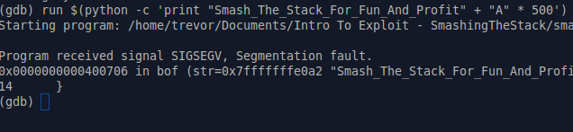

Perfect! The program took our input, then crashed because our input was too big for the buffer responsible for storing the input. This caused us to overwrite memory that didn’t belong to us. We’ve now confirmed this program is vulnerable to buffer overflows.

Let me take a moment here to explain in detail why the program crashed beyond “overwriting memory that doesn’t belong to us”. Inside of the CPU there’s a special register known as the ‘Return Instruction Pointer’ or $rip for short. This register is responsible for keeping track of the next instruction to be executed by the CPU via a memory address. When we pass an input too large for the buffer and cause an overflow we end up overwriting the address stored in this register causing the computer to try and execute an instruction that doesn’t exist.

What would happen though if we overwrote the address pointed to by $rip with our own valid address? Hypothetically it would be possible to control the execution flow of the program. The next step in this process is to learn how to craft our input such that we gain control over the Return Instruction Pointer.

This is done by first calculating the size of the buffer we have to write to before we begin overwriting the address pointed to by $rip. This is done by setting some breakpoints in the vulnerable function and monitoring the address pointed to by the $rsp register which always points to the top of the stack.

To make life easier for ourselves during this process open up GDB using the text ui layout this is done by opening gdb with the ‘-tui’ flag. Next we want to set GDB up to properly display the disassembly of our program. Execute the following commands within GDB: ‘set disassembly-flavor intel’ , ‘layout asm’. You can navigate the GDB text UI using the arrow keys on your keyboard or the page up / page down keys.

Next I want to set four breakpoints to monitor the execution flow of the program. One breakpoint at main, and three breakpoints within the bof() function shown below.

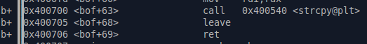

Run the program and pass the same input as we did previously. Continue execution until you land inside of the bof() function. Make note of the address pointed to by $rsp as you step through the instructions. We’re particularly concerned with the address pointed to by $rsp pre-leave instruction and the address pointed to by $rsp post-leave instruction.

We will use these two addresses to calculate the size of the buffer we need to overflow before we can control $rip. Examine the contents of the registers in GDB by using the command ‘info registers’

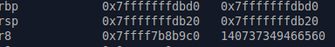

From the screenshot above pre-leave instruction the $rsp register points to the address “0x7fffffffdb20”. If you examine the contents of the stack after the strcpy call but before the leave instruction is executed you will see our input on the stack. Use the command ‘x/20xg $rsp’ to view the contents of the stack starting from the $rsp register.

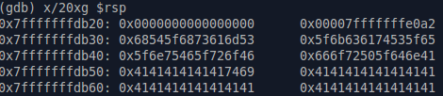

Examining the contents of the stack we can clearly see our input stored on the stack. The top of the stack begins at address 0x7fffffffdb20 pointed to by $rsp. The string “Smash_The Stack_For_Fun_And_Profit” begins with the ASCII values ‘7fffffffe0a2’, and ends at ‘0x666f72505f646e61’. Everything afterwards is all of the ‘A’ characters we passed to the program.

Post-leave instruction the $rsp register points to the address “0x7fffffffdbd8” as seen in the screenshot below.

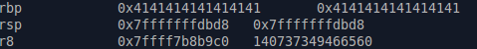

The reason $rsp points to the new address ‘0x7fffffffdbd8’ after the leave instruction is executed is because the functionality of leave instruction. Which serves to prepare the program to return back to another function. In this case the main() function was responsible for calling the bof() function we’re currently inside. Once the leave instruction is executed, the computer prepares to return back to main() function by first collapsing the stack frame used by bof(), and then pointing $rsp to the top of another stack frame.

The first piece of data contained in this frame is the address of the next instruction to be executed upon returning to main().

We now have both addresses we need to calculate the total size of the buffer we need to overflow before we begin writing our own address into the $rip pointer. The formula for calculating buffer size (also known as offset) is:

Buffer Size = (Address of $rsp Post-Leave Address) - (Address of $rsp Pre-Leave Address)

Buffer Size = (0x7fffffffdbd8) - (0x7fffffffdb20)

Buffer Size = 0xb8

0xb8 = 184 bytes

This means we can pass 184 total bytes of data to the program before we begin overwriting memory that doesn’t belong to us. That should mean that our previous input of “Smash_The_Stack_For_Fun_And_Profit” + “A” * 500 should have given us $rip control right? Unfortunately not, 0x414141414141 is not a valid memory address.

Besides that, on a 64-bit system the biggest address we can ever pass to the system is 6 bytes in length. Any address we provide beyond 6 bytes in length will raise an exception and cause the program to crash. This means if we pass 0x414141414141 as an address an exception will be raised, but the address 0x0000414141414141 is safe.

Let’s test this by creating a new payload to send to the program. Remember our total payload must be 184 bytes in size before we begin to overwrite $rip. Each character is occupying one byte on the stack. Therefore, the required string “Smash_The_Stack_For_Fun_And_Profit” is 34 bytes in length and ultimately we want to also provide a 6-byte address to jump to.

This means we need 144 bytes of filler characters before we begin to write to the desired location to control $rip.

184 - 34 - 6 = 144 bytes

Something like: $(python -c ‘print “Smash_The_Stack_For_Fun_And_Profit” + “A” * 144 + “B” * 6’) Should work for us. Re-run the program with this new payload and follow the same steps as above in GDB.

**Note:** As you monitor the execution of the program with the new input you may notice the addresses pointed to by $rsp differ are different from the originals. Don’t worry, the offset is still the same!

Below are screenshots of the addresses contained by $rsp and the content of the stack pre-leave and post-leave instruction respectively.

Pre-Leave:

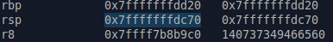

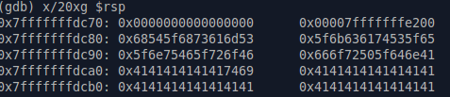

Post-Leave:

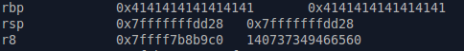

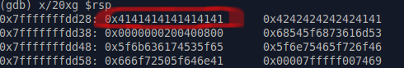

It seems our input is a little too large. If everything had gone according to plan the fake address, the 6 “B” characters we passed, represented by the ASCII value ‘0x42’ should be contained in the red box.

We must have calculated the number of filler characters required to overflow the buffer incorrectly, but how? If you’ve been attentive you may have noticed that pre-leave there are 11 bytes of filler before our input on the stack in the form of ‘0x0000000000000000’ and ‘0x0000’ before the input, we passed to the program begins.

This means we need to subtract 11 filler characters from our payload to achieve the desired outcome. Our new payload is

$(python -c ‘print “Smash_The_Stack_For_Fun_And_Profit” + “A” * 133 + “B” * 6’).

Repeat the previous steps.

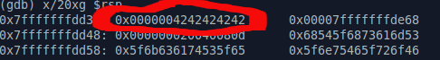

Perfect! Hypothetically we should now control $rip. Execute the return instruction in bof() and see what happens!

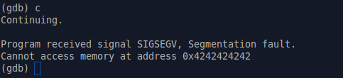

Success! When the return instruction was executed the computer tried to execute the next instruction pointed to by the address we provided: 0x424242424242 but couldn’t because there is no valid instruction contained at 0x424242424242.

But we do know the address of a valid instruction! The flag() function we’ve been wanting to jump to this entire time. What is the address of that function again?



Oh right, 0x40069d. All that’s left to do now is update our payload with this address.

**Note**: Addresses are placed into the stack backwards; this is known as ‘little-endian’ format. Additionally, addresses are always in hexadecimal format meaning we will need to update our payload with the following string: \x9d\x06\x40. The ‘x’ indicates we’re passing a hex value to the program and the ‘\’s separate each byte.

Final Payload: $(python -c ‘print “Smash_The_Stack_For_Fun_And_Profit” + “A” * 133 + “\x9d\x06\x40’)

Running the program with the above payload should result in the program jumping to the previously unexecuted flag() function.

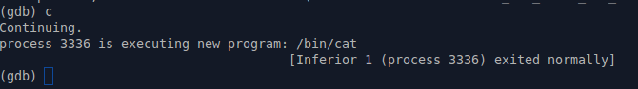

Bingo! The program jumps to the provided address and executes /bin/cat exactly like we had hoped for. The last thing to do is quit GDB and execute the program normally passing the payload in as input.



Flag: TXSTCS{You’re_Not_Supposed_To_Be_Here}

**Note:** For some unknown reason I had an issue with the last byte of my address being dropped. To solve this problem, I appended one extra byte of junk to my address knowing it would be cut off. The final address I passed was ‘\x99\x9d\x06\x04’. Try this method if you encounter a similar issue.

Pyjails

Introduction:Pyjails is a medium level exploitation challenge intended to teach students about the potential dangers of providing users access to unsecure services through a real world challenge. Additionally, this challenge provides students with some knowledge of deducing what services may be running in an unknown environment. Pyjails real name is [worst-pwn-ever](https://backdoor.sdslabs.co/challenges/WORST-PWN-EVER), a challenge written by Ashish Chaudhary as part of SDSLabs [Backdoor CTF](https://backdoor.sdslabs.co/) 2016.

Challenge: tocttou is an environmentalist. But some say he has a vicious motive and he uses nature to hide his dark side. We found a weird shell on his amazon (pun intended) web services. Can you tell us what is he up to?

Tip: he might shut down the machine if he notices you - and he will (maybe in 45 seconds).

Access: nc hack.bckdr.in 9008

Solving:Begin by opening a terminal and connecting to the netcat credentials provided: hack.bckdr.in 9008. Once you connect the only indication you’ve connected to the service is that your shell will output ‘>’ a classic indicator of a command line interface of some form.

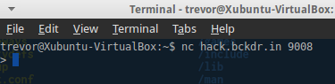

Before you can exploit any system you must first figure out what kind of environment or service is running on this remote machine. Begin by throwing some arbitrary commands at the service. I chose some common bash commands as a starting point.

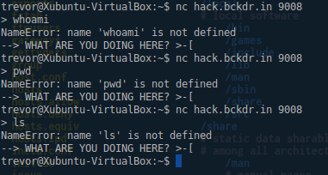

Interesting, we can probably rule out the target environment being bash. Where do we go from here then? Notice that each time you execute a command two pieces of information are output by the system. The first line output is the most important “NameError: name ‘COMMAND’ is not defined”, the second output “--> WHAT ARE YOU DOING HERE? >-[“ is output when the system “notices you” and then kicks you out every time you run an unknown command.

Let’s go to [Google](http://lmgtfy.com/?q=NameError%3A+name+is+not+defined) and see if we can’t dig up any information on this “NameError: name ‘COMMAND’ is not defined” nonsense. Well what do you know, the entire first page is full of Python based questions. This gives us a pretty strong hint that our target system is interpreting our commands through some sort of python script, quite possibly the python interpreter itself. Let’s test this theory out by trying to execute some very basic, python commands such as: “print”, “help”, and “quit()”.

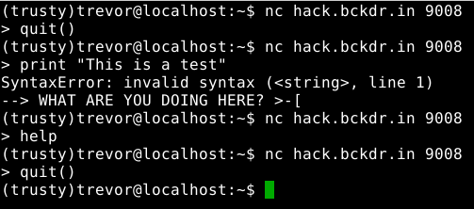

Interesting! The commands “help” and “quit()” execute perfectly but we don’t see any output from the system. Our “print” statement gives us a SyntaxError: for some strange reason. Either way, it would be a good guess to say we’re stuck in some stripped version of the python interpreter, now it’s time to try and exploit it.

Python has a function known as eval() which will evaluate a string of Python code if passed to the function. If used improperly, this function can be rather dangerous. You can read more about exploiting Python’s eval() statement [here](http://nedbatchelder.com/blog/201206/eval_really_is_dangerous.html).

Let’s see if we can’t launch a shell using the following piece of code:  ‘os.execl('/bin/sh','sh')’ Which is a simple python statement that says using the OS module, call the execl function and try to execute /bin/sh.

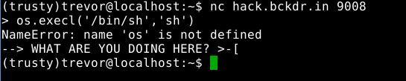

Well that’s unfortunate, it seems the OS module isn’t loaded. What if I told you there’s a way to force Python to import a module for you? You can read more about it [here](https://2013.picoctf.com/problems/pyeval/stage3.html).

Let’s try this piece of code now:  ‘__import__('os').execl('/bin/sh','sh')’

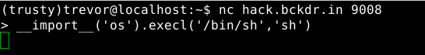

We certainly didn’t get kicked out of the target system, that’s a pretty good sign right? Let’s try running those bash commands from before again.

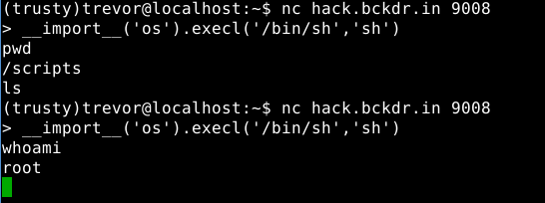

Bingo! We’ve successfully launched a root level shell on the target system, we essentially own this system now. But we’re not done yet, we still need to find the flag and complete this challenge.

Feel free to dig around the system and look around if you like, you won’t find the flag though. The question says that “tocttou is an environmentalist” which is somewhat poor hint that breaks down like this: environmentalist, environment-alist. Bash environment variables! Let’s see if the flag is hidden in the environment variables!

You can list the bash environment variables with the command: ‘printenv’

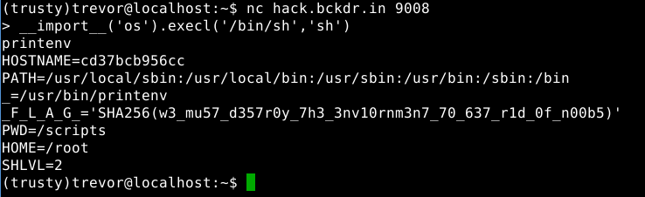

Flag: TXSTCS{w3_mu57_d357r0y_7h3_3nv10rm3n7_70_637_r1f_0f_n00b5}